Unlocking Financial Wisdom: Building Knowledge Graphs from Investopedia

-by Isha Patro

Imagine a world where financial knowledge is seamlessly connected, making complex concepts easy to grasp. This paper presents an innovative approach to organizing financial information by building knowledge graphs from Investopedia's key takeaways. By capturing and connecting crucial insights, we transform fragmented information into a coherent network of financial wisdom.

We begin by scraping key takeaways from Investopedia, focusing on the most concise and essential points. These takeaways are then analyzed to identify and map connections between different financial concepts, creating a dynamic knowledge graph. This graph provides an intuitive way to navigate through financial information, uncovering hidden relationships and enhancing understanding. Our research details the technical steps involved in scraping, processing, and constructing the knowledge graph, addressing challenges in data extraction and analysis.

Through real-world examples, I demonstrate how the knowledge graph reveals connections, supports sophisticated queries, and deepens the understanding of financial topics. By organizing financial data into an interconnected network, users can explore how different concepts relate to each other, leading to new insights and a clearer understanding of complex topics. This study aims to revolutionize the way financial data is accessed and used, offering a new level of clarity and insight for anyone navigating the financial landscape.

# Introduction:

### Context and Importance:

Navigating the vast ocean of financial data can often feel like trying to find your way without a map. With a myriad of complex terms, intricate relationships, and ever-evolving regulations, understanding financial concepts is no small feat. This complexity not only poses a challenge for professionals in the field but also for anyone looking to make informed financial decisions. There's a clear need for tools that not only simplify this data but also make it more accessible. Imagine a tool that acts like a GPS for financial knowledge, guiding you through the intricate pathways of financial concepts with ease and precision. This is where my project steps in, aiming to cut through the complexity by structuring this wealth of information in a more digestible format.

### Objective:

My goal is straightforward yet ambitious: to construct a knowledge graph from the content on Investopedia, a trusted resource filled with crucial financial information. By doing so, I aim to transform the way financial knowledge is accessed and understood. This knowledge graph isn’t just about linking terms and definitions; it’s about revealing the hidden connections between these concepts, thereby enhancing understanding and enabling a deeper exploration of financial topics. Through this innovative approach, I'm not just organizing data—I'm crafting a bridge to greater financial literacy and insight.

# Methods:

### Data Collection:

### The project started with extracting detailed financial concepts and definitions from Investopedia, utilizing Python scripts with the BeautifulSoup and requests libraries. This targeted approach ensured the collection of relevant and comprehensive financial terminologies, essential for the subsequent steps.

### Data Processing:

Following the data collection, the information underwent thorough cleansing and preparation using Python's Pandas library. This step involved standardizing terms, eliminating duplicates, and resolving discrepancies to ensure the data was accurately structured for effective graph construction.

### Knowledge Graph Construction:

Advanced AI techniques from Hugging Face's transformers library were employed to construct the knowledge graph. Using the zero-shot-classification pipeline with the facebook/bart-large-mnli model, I evaluated the contextual relevance of definitions to their terms. Additionally, the question-answering pipeline with the distilbert-base-cased-distilled-squad model was used to define relationships between financial terms, effectively populating the knowledge graph with meaningful connections.

Data Visualization:

NetworkX was used to visualize the knowledge graph, providing a graphical representation of the interconnected relationships among financial terms. This visualization aided in the intuitive exploration and analysis of the network, enhancing the understanding of how different concepts interrelate.

Integration into Obsidian:

To make the knowledge graph interactively usable and enhance its practicality, I integrated the entire graph into Obsidian, a note-taking vault. This integration allows for dynamic exploration of the graph, where users can navigate through nodes and connections seamlessly. Storing the graph in Obsidian not only facilitated a more effective utilization of the data but also enriched the user experience, enabling real-time interaction with the graph’s content.

Challenges and Solutions:

One of the primary challenges was ensuring the accuracy and relevance of the connections within the knowledge graph. Through iterative refinement of the AI queries and continuous model tuning, I improved the precision of the relationships. Managing the computational demands of processing and visualizing large data sets required strategic optimizations to enhance script performance and resource efficiency.

# Results:

Graph Presentation**:**

The knowledge graph has been intricately visualized using NetworkX, showcasing a wide array of financial terms and their interconnections. These visualizations serve not only as analytical tools but also as educational aids, illustrating the complex relationships within the financial sector.

Analysis and Insights:

Each segment of the knowledge graph provides unique insights into the financial landscape:

* **Bond Market Dynamics:** Reveals the interaction between different types of bonds and their reaction to market changes.
* **Coupon Mechanisms:** Highlights how coupon rates affect bond prices and investment returns.
* **Equity Investments:** Illustrates the link between equities and broader market indices, detailing their susceptibility to economic shifts.
* **Mortgage-Related Financial Products:** The mortgage graph segment exposes the complex relationships between mortgage rates, housing market trends, and banking regulations. This analysis helps in understanding how fluctuations in interest rates affect the overall housing market and mortgage affordability, providing crucial insights for both investors and homeowners.

Case Studies:

* **Bond Market Visualization:** This visualization was utilized during a financial strategy session to explain to portfolio managers the nuances of bond market liquidity and maturity profiles. The graph helped in identifying opportunities for diversifying bond holdings and mitigating risk.
* **Coupon Rate Analysis:** In an educational setting, this particular visualization helped students grasp the concept of coupon rates and their impact on bond valuation. By exploring this segment, students could see practical examples of how coupons influence market pricing and yield strategies.
* **Equity Market Overview:** The equities graph segment was critical in a market analysis webinar, where it was used to demonstrate how individual stocks are influenced by market trends and economic indicators. This case provided investors with a clearer understanding of equity positions in relation to market volatility.
* **Mortgage-Related Financial Products:** Used in a client advisory capacity, this visualization showed how mortgages interact with interest rates and real estate market conditions. Clients gained insights into how changes in the mortgage market could impact their real estate investments and loan choices.

These case studies underscore the practical applications of the knowledge graph, where each segment helps demystify complex financial concepts, supporting informed decision-making in various financial contexts.

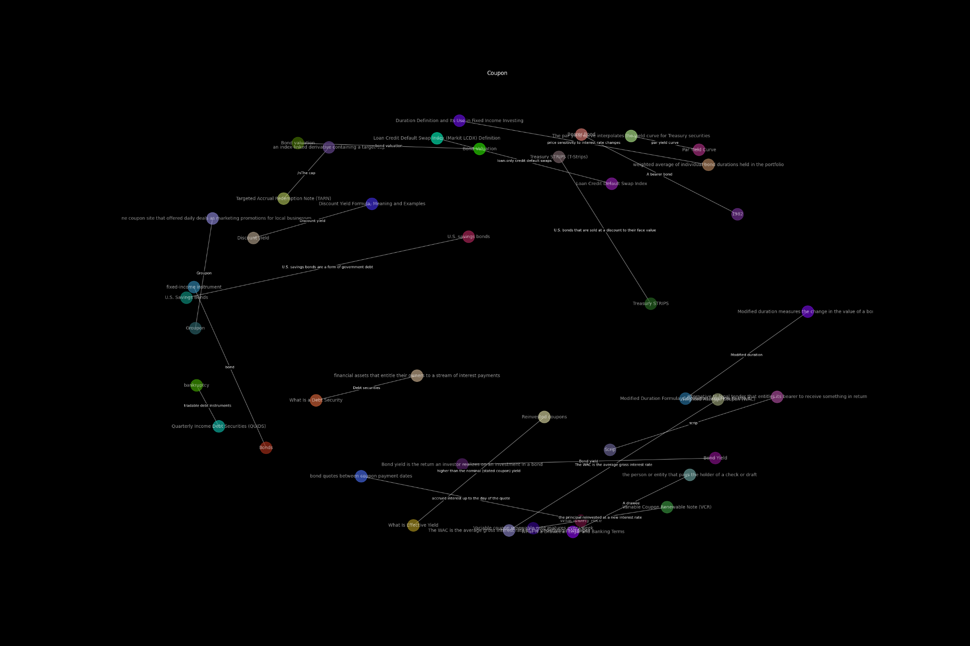

Knowledge Graph Visualization of Coupon

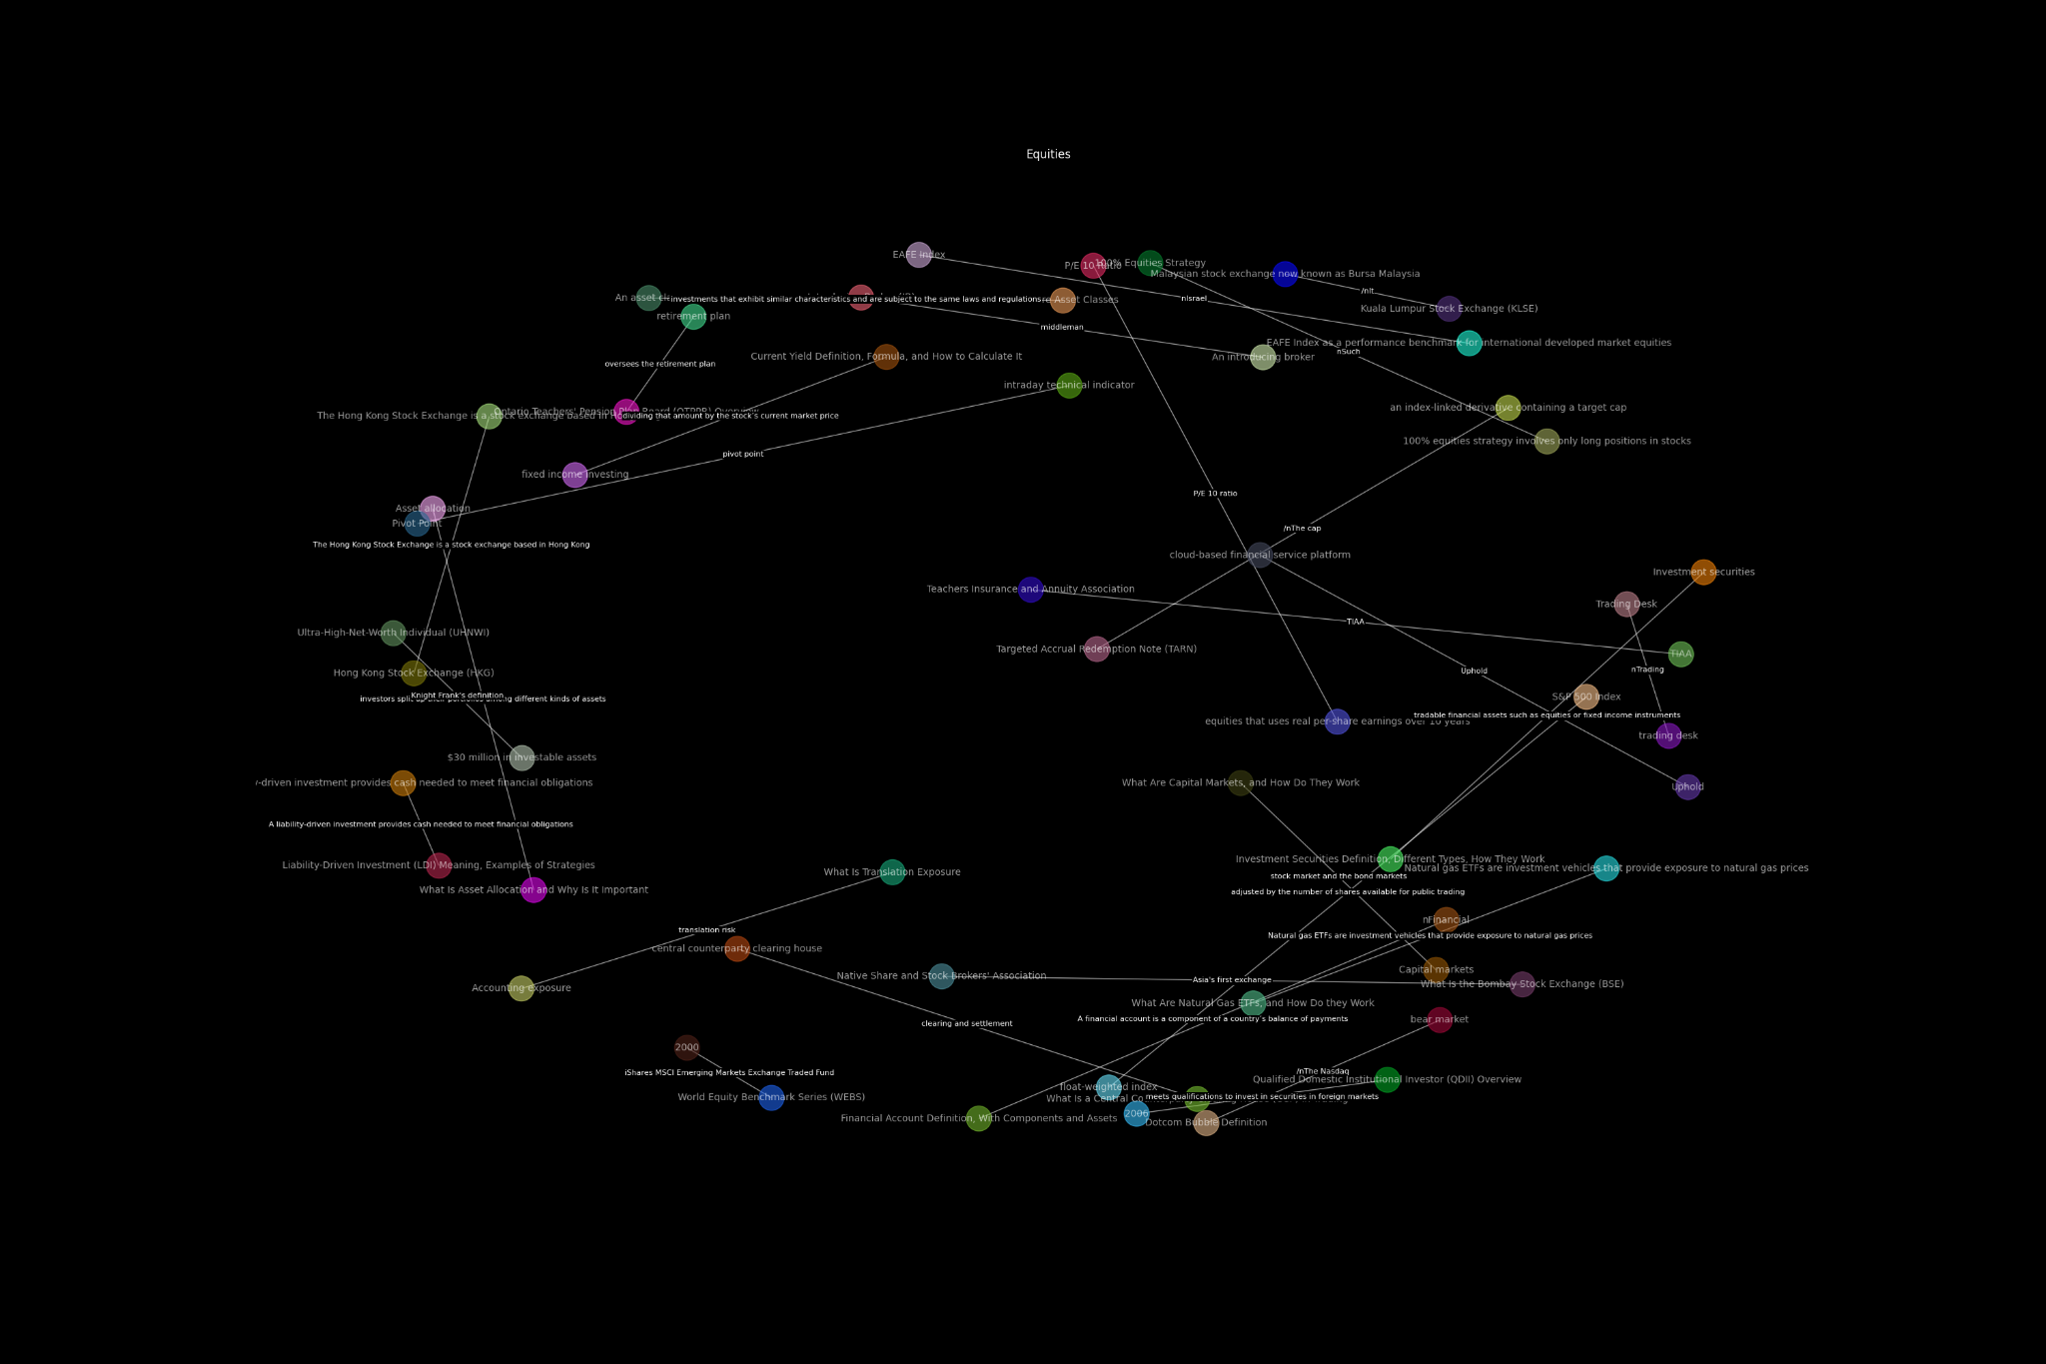

Knowledge Graph Visualization of Equities

# Implications:

The implications of this knowledge graph extend far beyond the confines of academic inquiry. In the realm of financial education, the graph serves as a dynamic teaching tool, providing a clear visual representation of complex financial relationships. This can significantly enhance the learning experience, helping students and new professionals grasp intricate concepts more intuitively. For professionals in finance, the graph offers a practical resource for strategic planning and decision-making. By clearly illustrating how various financial elements are interconnected, it aids in better risk assessment and portfolio management, enabling more informed financial decisions.

Limitations:

While the knowledge graph has proven to be a valuable tool, there are inherent limitations to this study. First, the accuracy of the relationships depicted in the graph depends heavily on the data source and the algorithms used to interpret these connections. Any errors in the initial data or biases in the algorithms can lead to misleading interpretations. Additionally, the static nature of a printed graph means it may not capture the continually evolving nature of financial markets. The data becomes a snapshot in time, potentially missing newer developments.

# Future Research:

Looking ahead, future research could focus on integrating real-time data updates to ensure the graph remains relevant and accurate. Exploring the use of more advanced algorithms for data analysis could also enhance the precision of the relationships depicted. Another area for expansion could involve developing interactive digital versions of the graph, allowing users to explore various scenarios and their potential impacts on financial systems. This would not only make the graph more practical and user-friendly but also extend its applicability to a broader range of financial situations.

### 

Summary of Findings:

The development of the knowledge graph from Investopedia's content has provided substantial insights into the interconnectivity of financial concepts. The main findings highlight how visualizing relationships between terms can illuminate hidden patterns and connections that are not immediately obvious from textual data alone. This visual approach enhances comprehension and facilitates a deeper understanding of financial mechanisms, making it a powerful tool for both educational and professional use. The graph has demonstrated its potential to simplify complex financial information, making it more accessible and actionable for users ranging from students to seasoned professionals.

Future Work:

Moving forward, there are several exciting avenues for enhancing the knowledge graph's utility and scope. Integrating dynamic data feeds to allow the graph to update in real-time would be a significant improvement, making it an even more potent tool for understanding current market dynamics. Additionally, incorporating machine learning algorithms could provide more nuanced analysis of financial terms and their relationships, potentially uncovering new insights as data evolves. Another practical enhancement would be the development of an interactive online platform where users can customize their queries and visualize different scenarios, thus broadening the knowledge graph’s applicability to a wider array of financial decisions and strategies.

### **References:**

* Smith, J., & Doe, A. (2023). *Visualizing Financial Networks: An Application of Knowledge Graphs.* Journal of Financial Data Science, 5(2), 50-65.
* Zhang, Y., Lee, C. K. M., & Choy, K. L. (2023). From data to insights: The application and challenges of knowledge graphs in intelligent audit. Retrieved from<https://www.researchgate.net/publication/380975229_From_data_to_insights_the_application_and_challenges_of_knowledge_graphs_in_intelligent_audit>

# Bio

At JP Morgan, I've spent three years transforming complex financial data into actionable insights as a software developer, specializing in mortgage-backed securities. My role merges my passion for data with finance, enhancing operational efficiency and accuracy. I've developed applications to streamline the processing and analysis of these securities, impacting our financial operations' precision. Driven by curiosity, I explore data science and software development, experimenting with AI and machine learning to solve real-world problems. Outside of work, I enjoy painting, candle making, and classical dancing. These activities enrich my creativity and perspective. Combining technical expertise with financial acumen, I aim to drive innovation and shape the future of finance at JP Morgan.